1.Use Figma to create an interactive diagram illustrating the components of a basic
cellular system

1. Interactive diagram of a basic cellular system
This is the FigJam diagram that opened in the chat. It shows these components:
- The mobile station (handset and SIM) reaches two base transceiver stations, Cell A and Cell B, over the air interface. The Cell B link represents handoff and roaming.
- Both base stations connect to the base station controller, which connects to the mobile switching center.
- The mobile switching center links to the visitor location register, home location register, authentication center and equipment identity register. It reaches the PSTN/Internet through the gateway MS

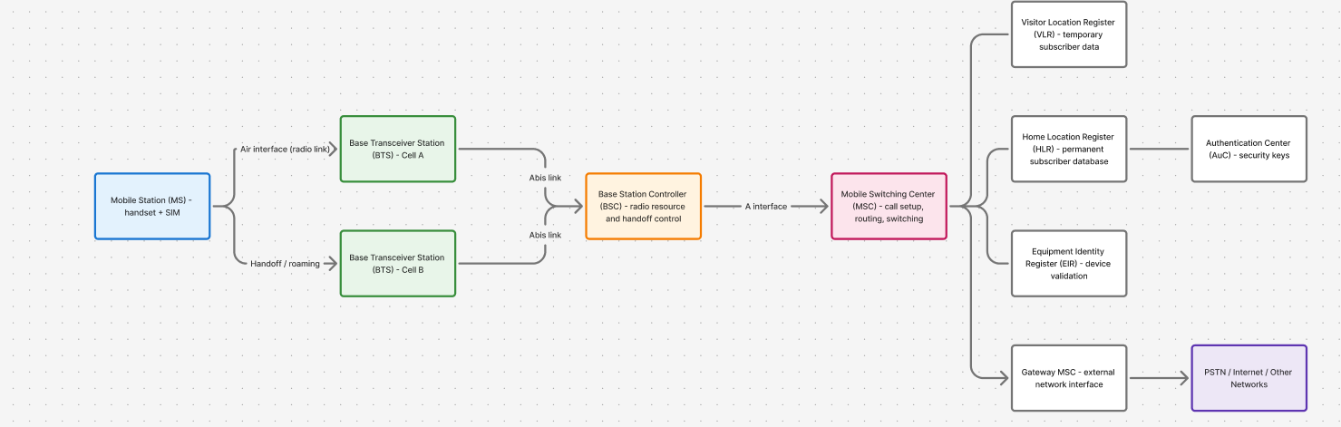

2.Design a user interface prototype for a mobile station using Figma, considering connectivity and convenience. finish using figma
The file is Mobile Station UI Prototype. It has four 390×844 screens:
- Home: a signal and speed card showing the connected tower and "Handoff ready", quick toggles for Data, Wi-Fi, Airplane and Roaming, and recent calls.
- Dialer: a large number display, a keypad and a green call button.
- Connectivity: signal strength in dBm, the connected tower, network type, and toggles for Airplane mode, Mobile data, Wi-Fi calling, Data roaming and HD Voice.
- In Call: a call timer, an "HD Voice | Strong signal" indicator, call controls and a red end button.

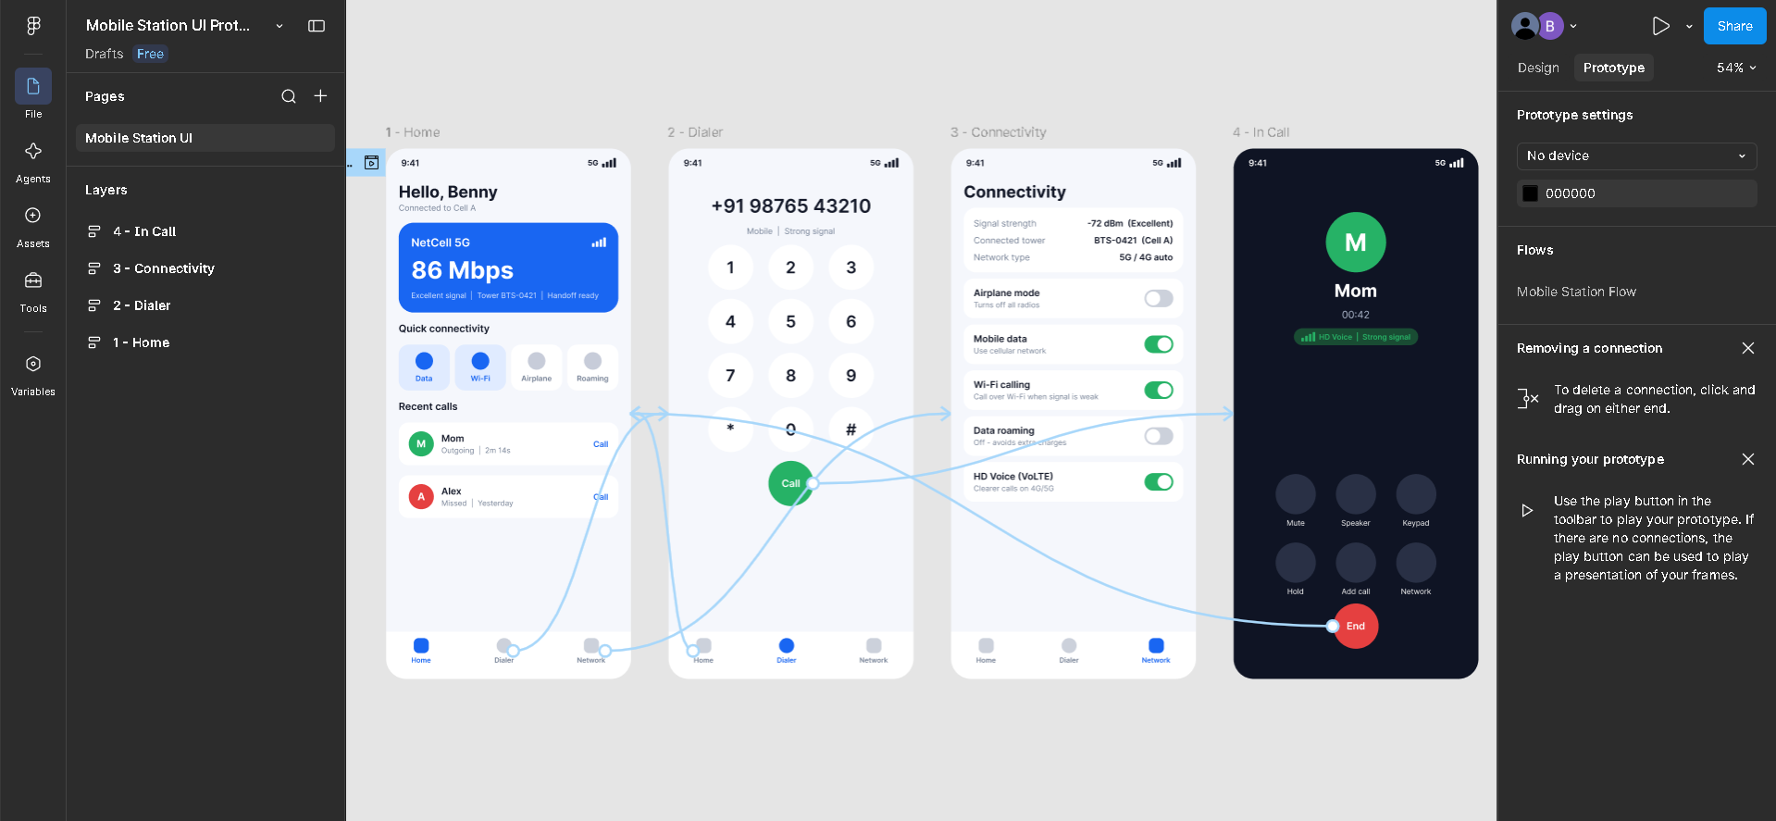

3.Develop a flowchart in Figma depicting the operation of a Network Switching Subsystem in a mobile cellular system.
https://www.figma.com/board/etH7ePuSHYCue2TyODHbxa/NSS-Operation-Flowchart?node-id=0-1&p=f&t=6M1HjsJhtLYdrMr2-0
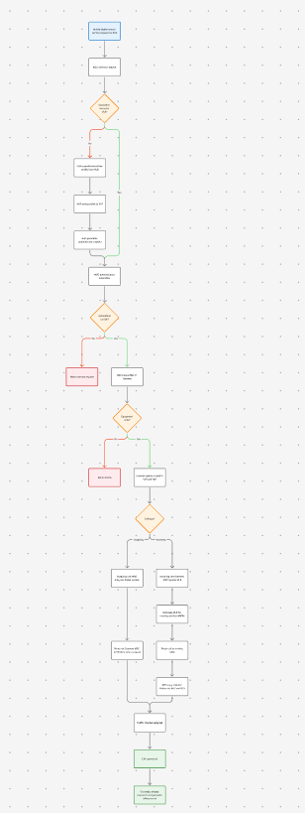

4.create a visual representation in Figma highlighting the key elements of mobile
network protocol stacks.

I've made the protocol stack diagram as a new Figma design file: Mobile Network Protocol Stacks. I checked it in a screenshot and it renders cleanly.
It shows the GSM control-plane stack as four columns: the mobile station, BTS, BSC and MSC. The labels on the Um (radio), Abis and A interfaces sit between the columns.
The rows are colour-coded by layer:
- Layer 3 (blue): connection management (CM), mobility management (MM) and radio resource (RR) / BSSAP.
- Layer 2 and transport (orange): LAPDm and LAPD for signalling on the radio and Abis links, then SCCP and MTP levels 3 and 2 for signalling between the BSC and MSC.
- Layer 1 (green): the radio link (TDMA, GMSK) and E1/PCM digital links

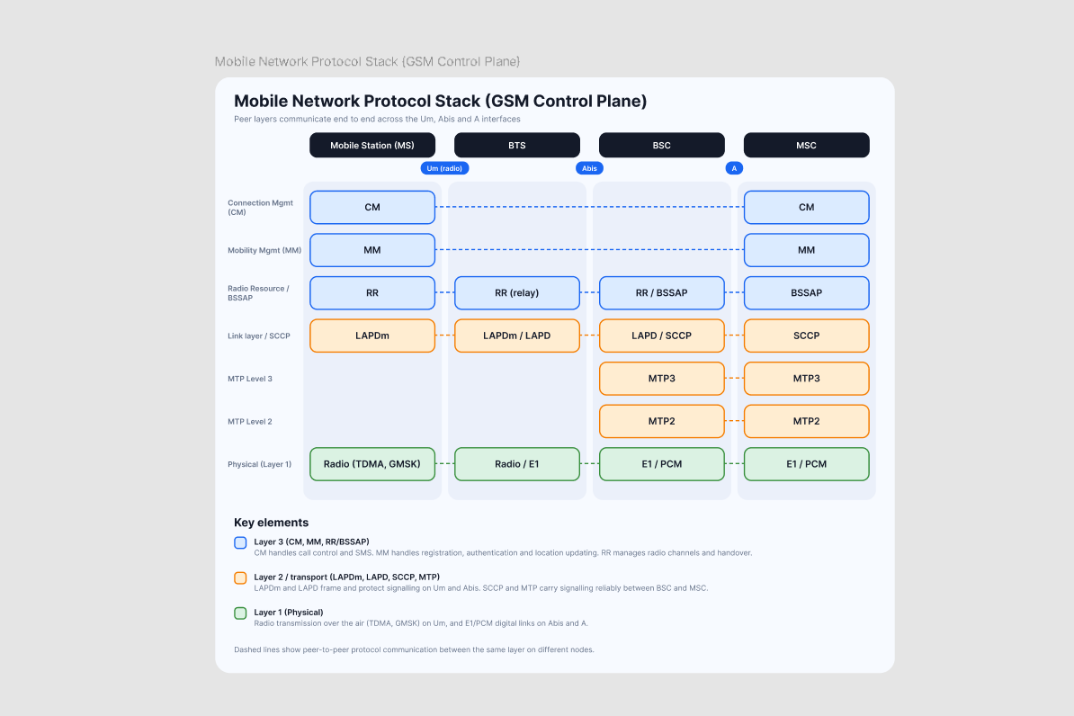

5.Design a wireframe for a mobile application that incorporates localization features
using Figma
It's a grayscale, low-fidelity wireframe with four screens:
- Language selection: languages are listed in their own scripts (English, हिन्दी, தமிழ், العربية, Español, Français), with a search field and a "detected region" card showing India, INR and metric. Arabic is marked as right-to-left.
- Home (English, left-to-right): the header has a location pill and a language chip. Prices show ₹, distances are in km and dates use the regional format.
- Home (Arabic, right-to-left): the same screen fully mirrored, including element order, text alignment and bottom-nav order. The text, currency, numerals and date are localized.
- Language and region settings: separate controls for language, region, currency, units, date format and time format. There's an auto-detect location toggle and a live preview of how numbers and dates will look
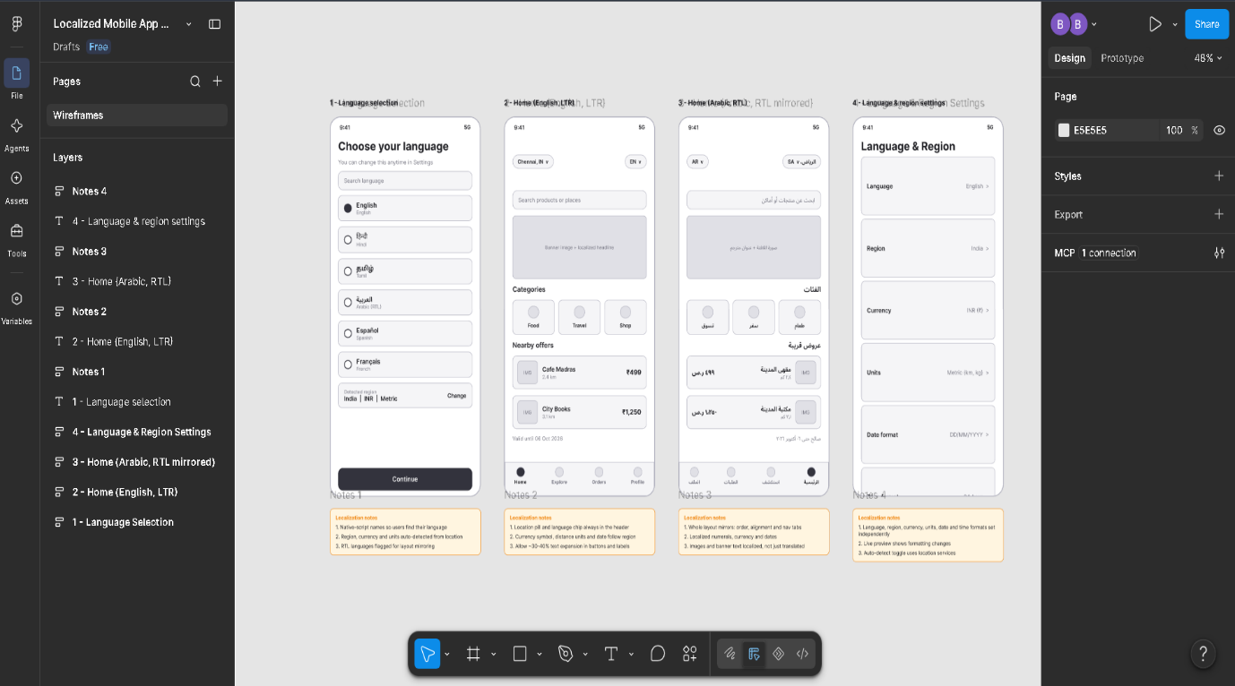

6. Figma to simulate a handoff scenario in a mobile network and visualize the
Process
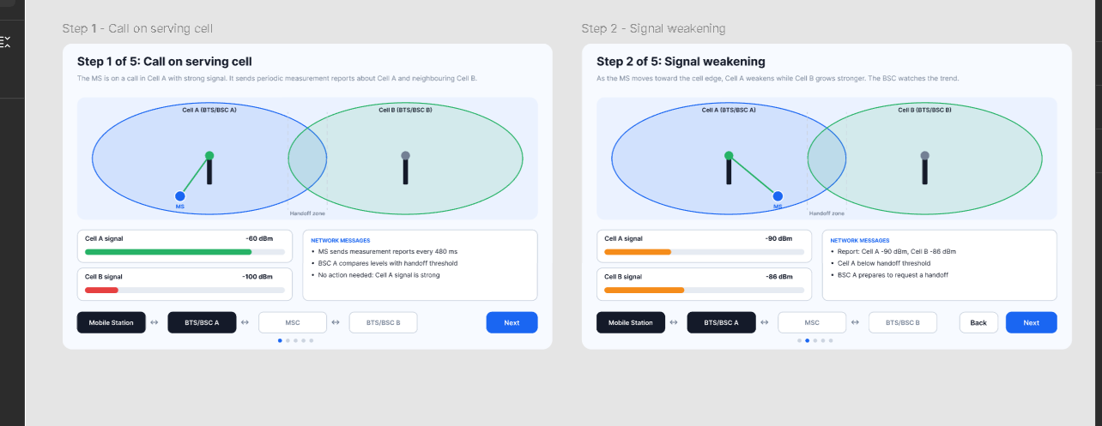
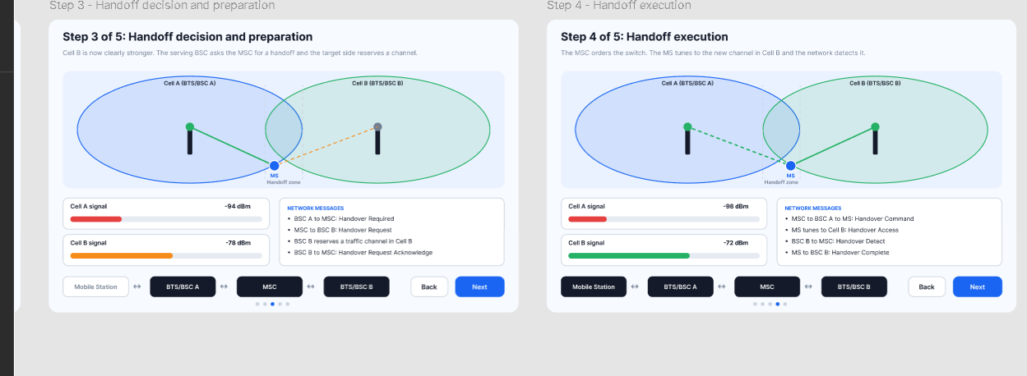
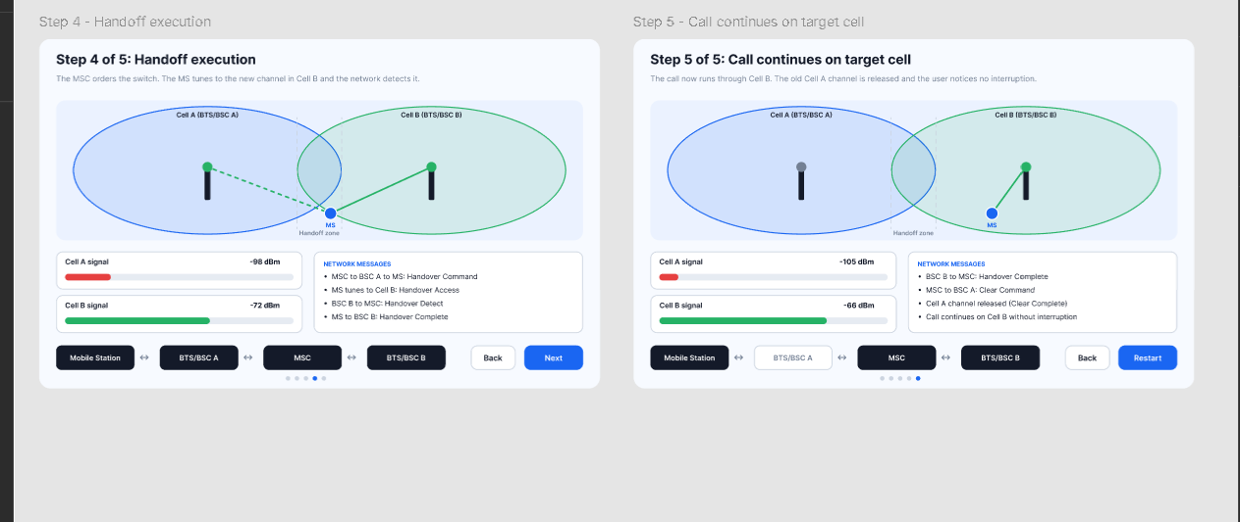
7.Develop a dashboard prototype in Figma displaying performance criteria for a
cellular system.
Cellular Performance Dashboard. It has two linked 1440×940 screens. I checked both in screenshots and fixed two overlapping labels. The figures are sample data, not real network measurements.
Overview screen
- KPI cards: call setup success rate (98.7%), call drop rate (0.8%), handover success rate (97.9%), average throughput (42.6 Mbps) and cell availability (99.94%). Each shows its change and target, with a colour bar that is green when on target and orange when watch-listed.
- Call drop rate chart: a 24-hour line chart with a red 2% target line.
- Traffic load bar chart: six cells, with the busiest one, C03, highlighted in orange.
- Cell performance table: per-cell setup success, drop rate, handover success, load and status. The C03 row is highlighted as degraded.
- Signal quality distribution: four bands from Excellent to Poor, based on signal strength.
- Controls: the 1h / 24h / 7d chips and the Live indicator are visual only and don't change the data
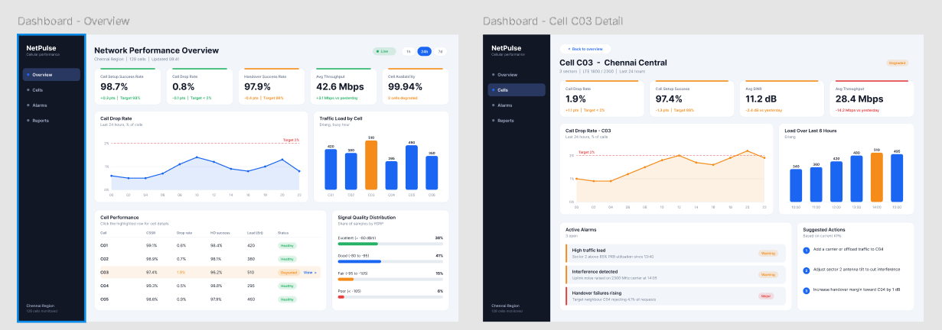

8.Create an infographic in Figma explaining the concept of Public Land Mobile
Network (PLMN)..

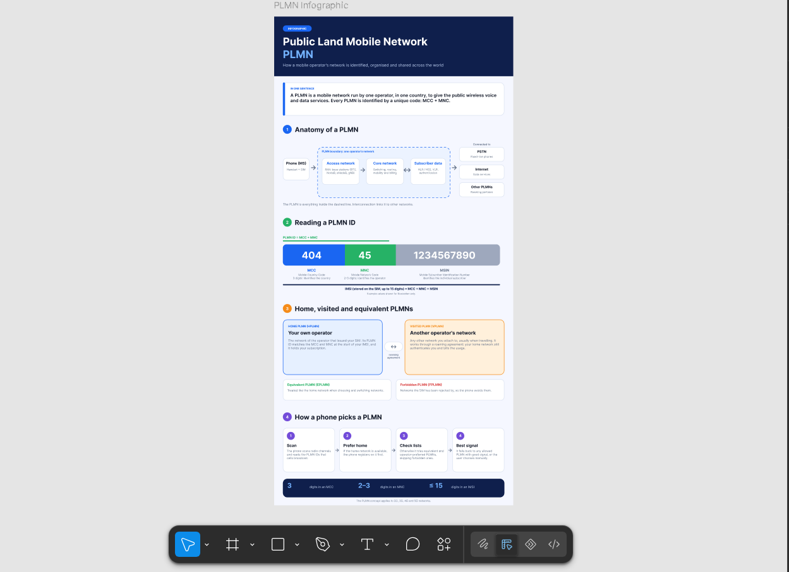
9.Develop a user interface prototype for a GSM service using Figma.
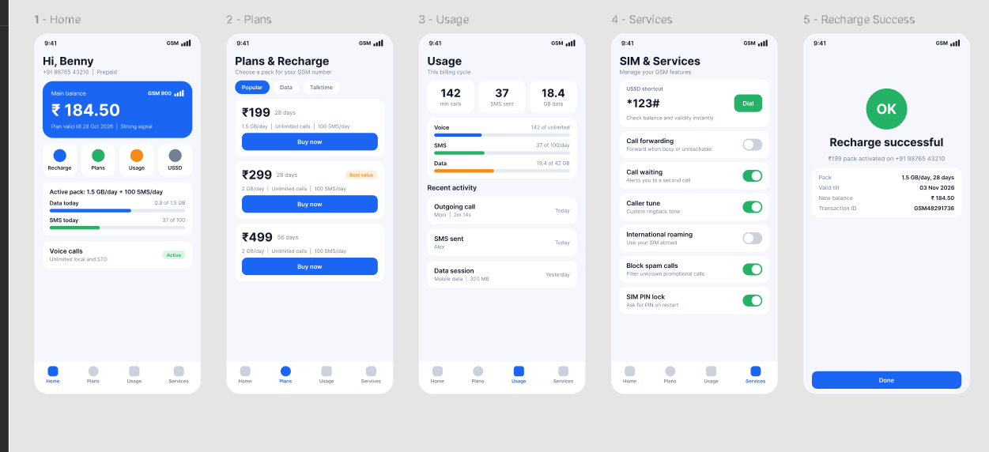
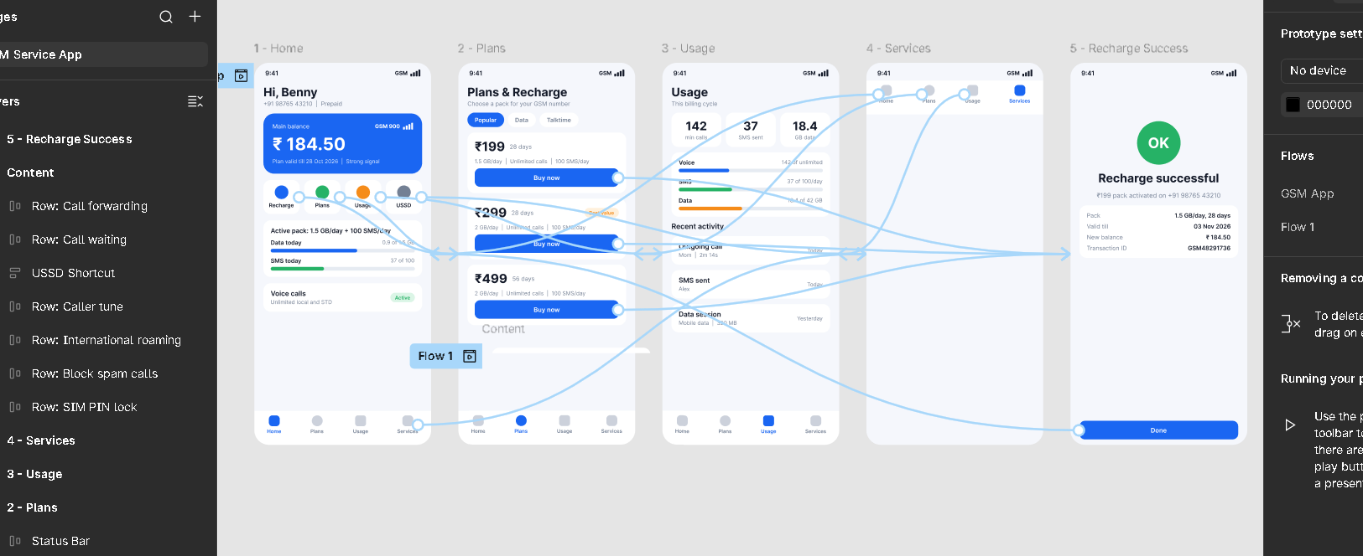
10. Create a visual representation in Figma showcasing the differences between
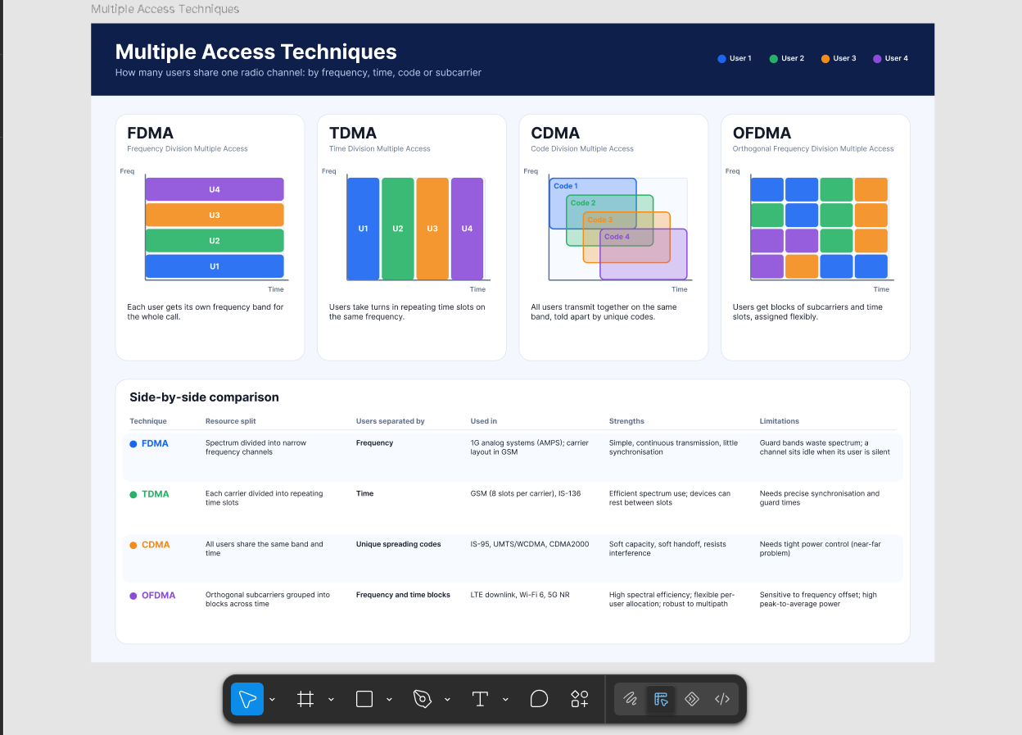

- Design a wireframe for a mobile application that incorporates security measures
using Figma
https://www.figma.com/design/Cp6SprSz1fd7bcBZUCQwDB/Secure-Mobile-App-Wireframe?node-id=0-1&p=f&t=TPL7LG7ufJilFm3c-0
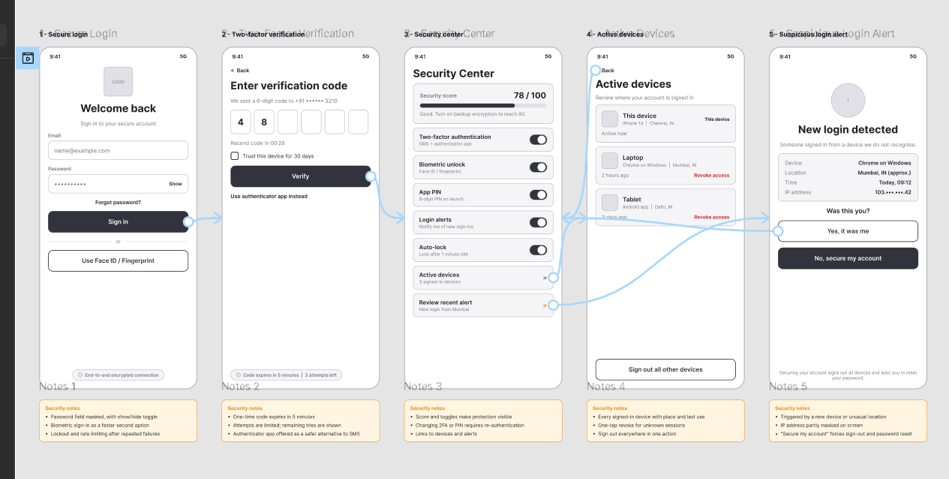
12.Use Figma to create an interactive diagram illustrating the evolution from 1G to 5G.1

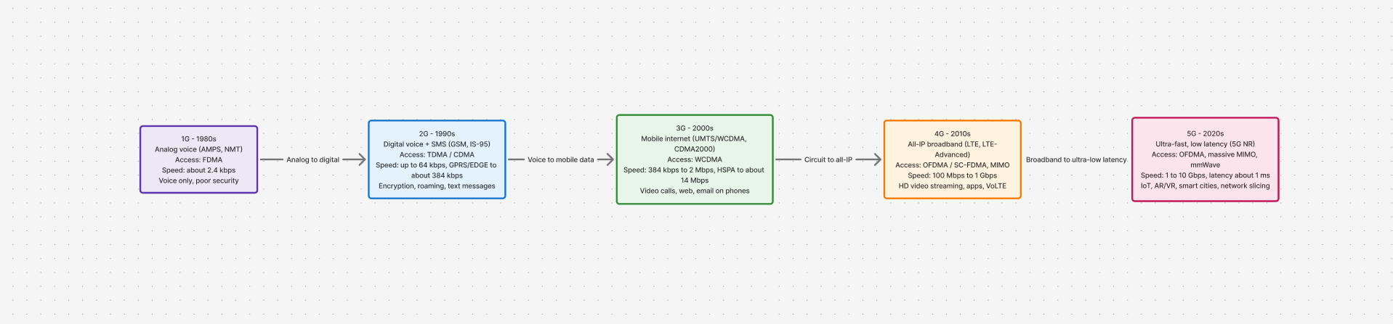

13.Design an infographic in Figma comparing mobile communication and mobile computing

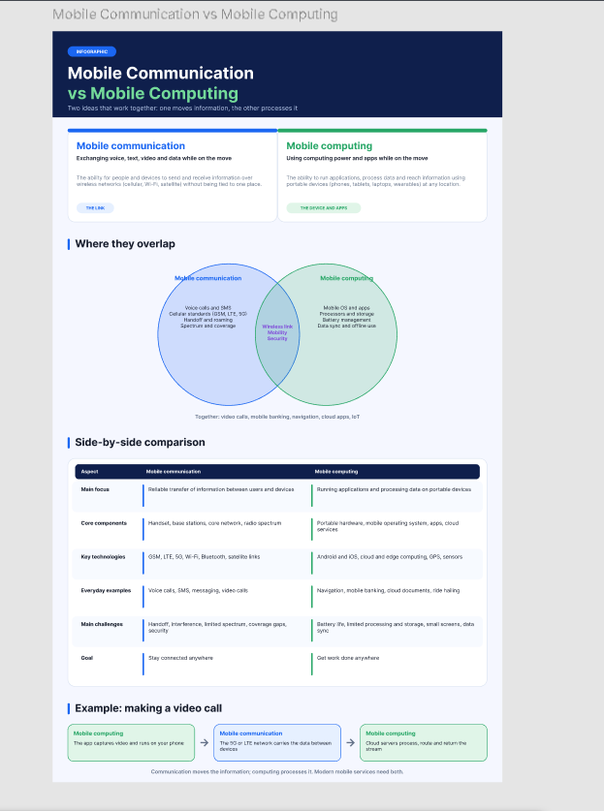

14. Develop a flowchart in Figma explaining the operation of General Packet Radio Service (GPRS)
https://www.figma.com/board/wHOFzqgOiDgyQPVETIT8W8/GPRS-Operation-Flowchart?node-id=0-1&p=f&t=Pe65p1sSgGrmgtqv-0

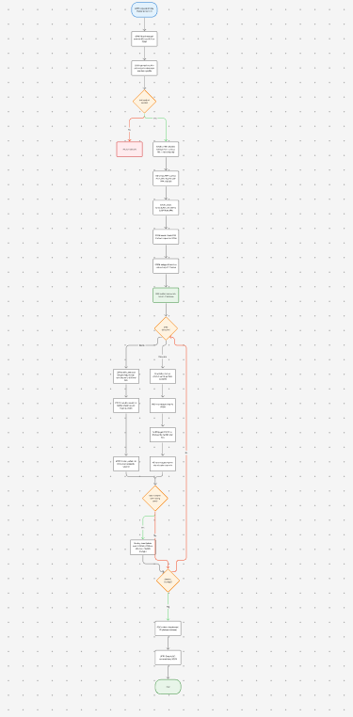

15.Develop a wireframe for a mobile application that addresses challenges related to ad hoc wireless networks using Figma

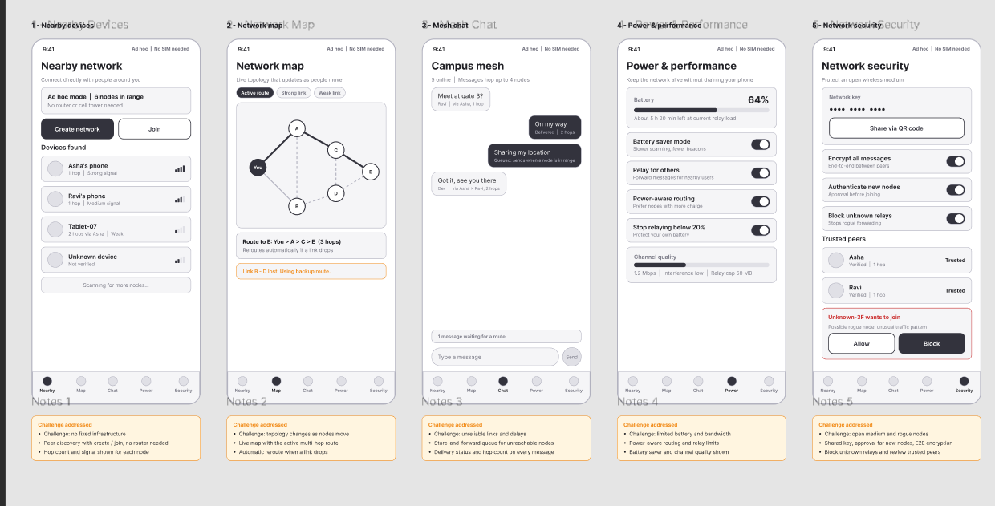
https://www.figma.com/design/udLbVBKp20MXE4ewNTUdNI/Ad-Hoc-Network-App-Wireframe?node-id=0-1&p=f&t=iPaWHaQeZV8GuaZt-0

